Experimental Results
Experimental Pipeline
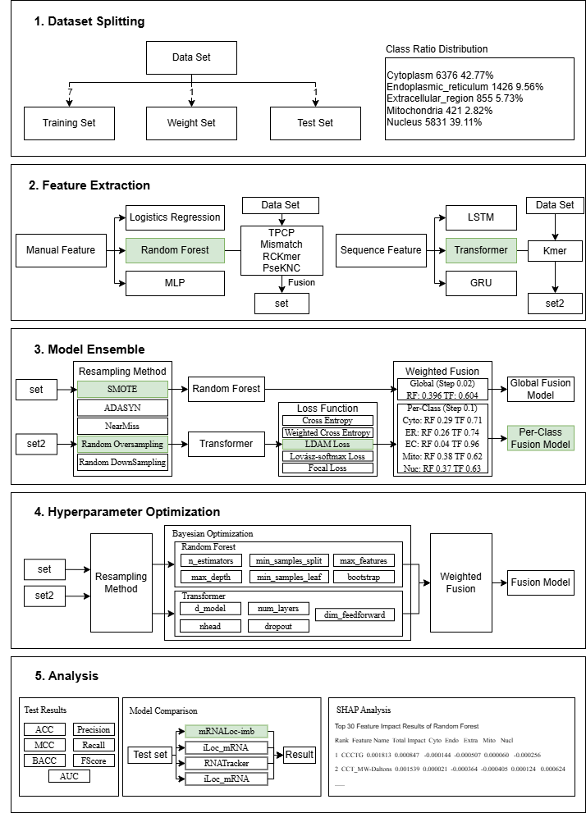
- Dataset Splitting
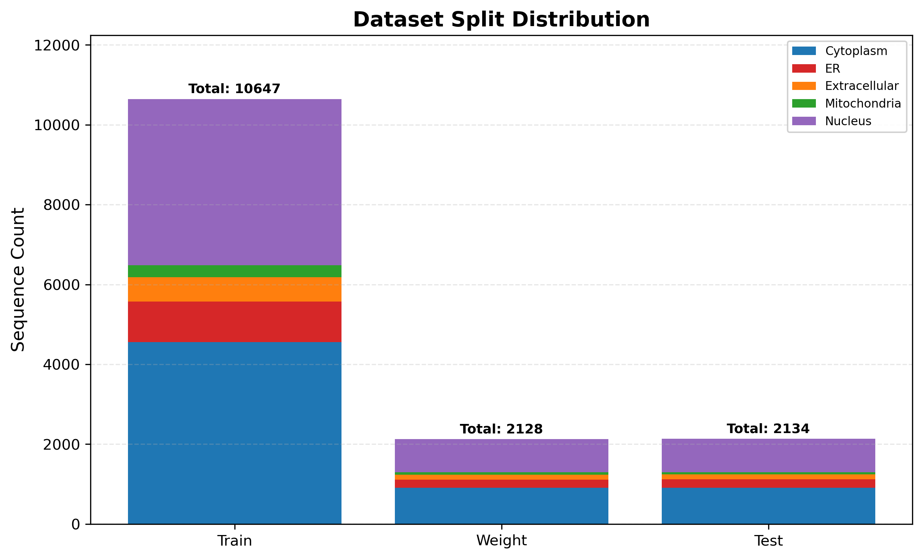
Split Summary (5:1:1)
Location | Train | Weight | Test | Total
Cytoplasm | 4554 | 910 | 912 | 6376
Endoplasmic_reticulum | 1018 | 203 | 205 | 1426
Extracellular_region | 610 | 122 | 123 | 855
Mitochondria | 300 | 60 | 61 | 421
Nucleus | 4165 | 833 | 833 | 5831
Total | 10647 | 2128 | 2134 | 14909

- Feature Extraction
Logistic Regression：
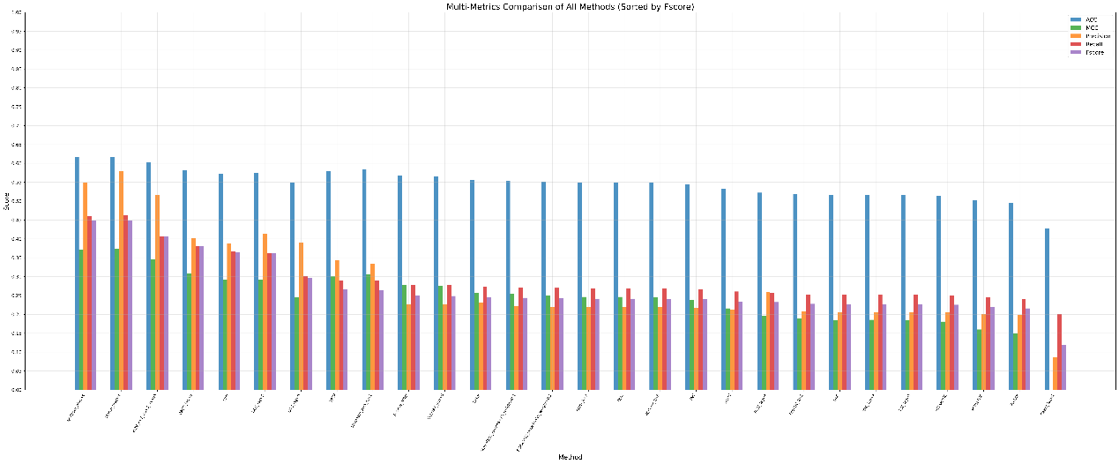
All Methods Ranking (Sorted by Fscore)
Rank | Method Name | Parameters | ACC | MCC | Precision | Recall | Fscore
1 | NMBroto | nlag=4 | 0.616 | 0.3706 | 0.5491 | 0.461 | 0.4486
2 | Moran | nlag=4 | 0.6173 | 0.3726 | 0.58 | 0.4623 | 0.4477
3 | W2V | k=7;ws=5;vs=64 | 0.6026 | 0.3447 | 0.5157 | 0.4073 | 0.4066
4 | DACC | lag=6 | 0.5821 | 0.3075 | 0.4029 | 0.3809 | 0.3803
5 | MMI | - | 0.5723 | 0.2909 | 0.3873 | 0.3659 | 0.3646
6 | DCC | lag=5 | 0.5739 | 0.2925 | 0.4143 | 0.3615 | 0.3628
7 | DAC | lag=6 | 0.5484 | 0.2448 | 0.3898 | 0.3004 | 0.2974
8 | TPCP | - | 0.5801 | 0.3002 | 0.3439 | 0.2903 | 0.267
9 | Mismatch | k=5;m=1 | 0.5831 | 0.3051 | 0.3331 | 0.2893 | 0.2638
10 | Z-curve | 48bit | 0.5669 | 0.2773 | 0.2268 | 0.2778 | 0.2492
11 | CKSNAP | gap=6 | 0.5655 | 0.2755 | 0.2264 | 0.2772 | 0.2486
12 | DPCP | - | 0.5554 | 0.2568 | 0.2322 | 0.2728 | 0.2455
13 | SCPseDNC | lamada=10;weight=0.1 | 0.5545 | 0.255 | 0.2218 | 0.2716 | 0.2438
14 | SCPseTNC | lamada=10;weight=0.1 | 0.5506 | 0.2488 | 0.2203 | 0.2698 | 0.2421
15 | Kmer | k=2 | 0.5491 | 0.2462 | 0.2197 | 0.2691 | 0.2414
16 | DNC | - | 0.5491 | 0.2462 | 0.2197 | 0.2691 | 0.2414
17 | RCKmer | k=3 | 0.5482 | 0.2456 | 0.2196 | 0.2688 | 0.241
18 | TNC | - | 0.5448 | 0.2384 | 0.218 | 0.2669 | 0.2396
19 | ASDC | - | 0.5332 | 0.2159 | 0.2132 | 0.2604 | 0.2343
20 | TACC | lag=6 | 0.5222 | 0.1958 | 0.2592 | 0.256 | 0.2324
21 | PseKNC | k=2 | 0.5181 | 0.1894 | 0.2071 | 0.2529 | 0.2276
22 | NAC | - | 0.5155 | 0.1846 | 0.2061 | 0.2516 | 0.2264
23 | TAC | lag=4 | 0.5166 | 0.1855 | 0.2065 | 0.2515 | 0.2263
24 | TCC | lag=5 | 0.5154 | 0.184 | 0.2065 | 0.2511 | 0.2261
25 | PCPseDNC | - | 0.5135 | 0.1808 | 0.2053 | 0.2504 | 0.2254
26 | PCPseTNC | - | 0.5015 | 0.1599 | 0.2005 | 0.2445 | 0.2199
27 | PseEIIP | - | 0.4959 | 0.1491 | 0.1986 | 0.2407 | 0.2157
28 | Geary | lag=2 | 0.4277 | 0 | 0.0855 | 0.2 | 0.1198

Random Forest：
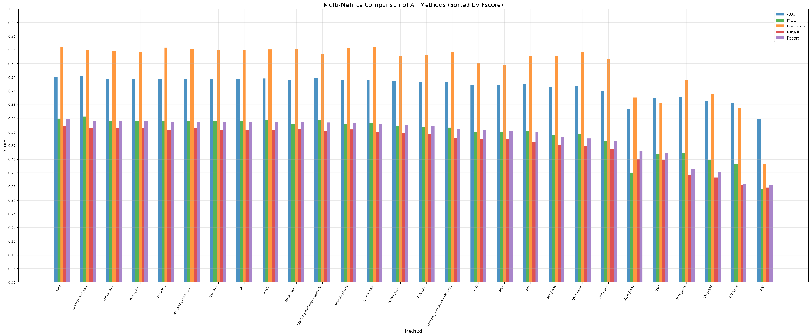
All Methods Ranking (Sorted by Fscore)
Rank | Method Name | Parameters | ACC | MCC | Precision | Recall | Fscore
1 | TPCP | - | 0.7501 | 0.5991 | 0.8611 | 0.5701 | 0.5982
2 | Mismatch | k=5;m=1 | 0.7545 | 0.6062 | 0.8512 | 0.5622 | 0.5919
3 | RCKmer | k=4 | 0.7457 | 0.5916 | 0.8449 | 0.5655 | 0.5905
4 | PseKNC | k=3 | 0.7457 | 0.5917 | 0.8411 | 0.5623 | 0.5884
5 | PCPseTNC | - | 0.7453 | 0.5907 | 0.8586 | 0.556 | 0.5867
6 | W2V | k=10;ws=5;vs=64 | 0.7445 | 0.5895 | 0.8533 | 0.5653 | 0.5865
7 | Kmer | k=3 | 0.7458 | 0.5916 | 0.8485 | 0.5582 | 0.5864
8 | TNC | - | 0.7458 | 0.5916 | 0.8485 | 0.5582 | 0.5864
9 | PseEIIP | - | 0.7465 | 0.5928 | 0.8517 | 0.5571 | 0.586
10 | Moran | nlag=4 | 0.7377 | 0.5786 | 0.8527 | 0.5608 | 0.5854
11 | SCPseTNC | lamada=10;weight=0.1 | 0.7468 | 0.5931 | 0.8345 | 0.5539 | 0.5851
12 | NMBroto | nlag=4 | 0.7382 | 0.5791 | 0.8568 | 0.5596 | 0.5847
13 | Z-curve | 48bit | 0.7415 | 0.5843 | 0.8604 | 0.5509 | 0.5792
14 | CKSNAP | gap=3 | 0.7349 | 0.5731 | 0.8292 | 0.546 | 0.5755
15 | PCPseDNC | - | 0.732 | 0.5684 | 0.8311 | 0.5443 | 0.5723
16 | SCPseDNC | lamada=10;weight=0.1 | 0.7313 | 0.5664 | 0.8406 | 0.5273 | 0.5616
17 | DNC | - | 0.7221 | 0.5514 | 0.8037 | 0.5244 | 0.5563
18 | DPCP | - | 0.7213 | 0.5506 | 0.7947 | 0.5237 | 0.5533
19 | MMI | - | 0.7238 | 0.5539 | 0.8293 | 0.5129 | 0.5492
20 | DCC | lag=4 | 0.7148 | 0.5386 | 0.8259 | 0.5026 | 0.5304
21 | DACC | lag=6 | 0.718 | 0.5437 | 0.8437 | 0.4978 | 0.5268
22 | DAC | lag=6 | 0.7012 | 0.5152 | 0.8165 | 0.4878 | 0.5152
23 | Geary | lag=3 | 0.6321 | 0.3996 | 0.6765 | 0.4509 | 0.481
24 | ASDC | - | 0.6735 | 0.4701 | 0.6543 | 0.4464 | 0.4709
25 | TACC | lag=6 | 0.6784 | 0.4738 | 0.7375 | 0.3923 | 0.415
26 | TAC | lag=6 | 0.6634 | 0.4484 | 0.6889 | 0.3842 | 0.403
27 | TCC | lag=6 | 0.6565 | 0.4353 | 0.6367 | 0.3553 | 0.3597
28 | NAC | - | 0.5953 | 0.3409 | 0.4323 | 0.3466 | 0.3566

MLP
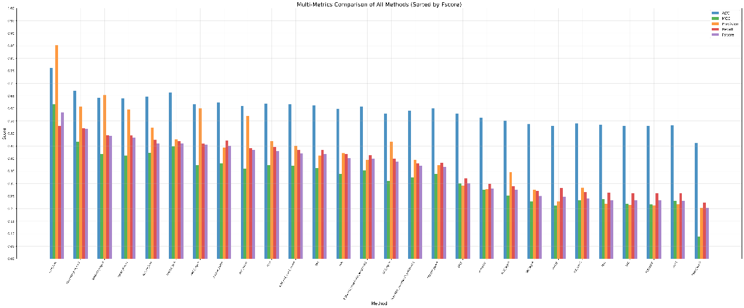
All Methods Ranking (Sorted by Fscore)
Rank | Method Name | Parameters | ACC | MCC | Precision | Recall | Fscore
1 | Kmer | k=8 | 0.7606 | 0.6158 | 0.8517 | 0.5292 | 0.5841
2 | Mismatch | k=6;m=1 | 0.6697 | 0.466 | 0.6072 | 0.5205 | 0.5193
3 | NMBroto | nlag=4 | 0.6423 | 0.418 | 0.6532 | 0.4927 | 0.4902
4 | Moran | nlag=4 | 0.6391 | 0.4123 | 0.5948 | 0.4918 | 0.4826
5 | RCKmer | k=6 | 0.6467 | 0.422 | 0.5234 | 0.4751 | 0.461
6 | PseKNC | k=6 | 0.6629 | 0.4494 | 0.4771 | 0.4697 | 0.4592
7 | DACC | lag=6 | 0.6163 | 0.3737 | 0.6009 | 0.459 | 0.4549
8 | Z-curve | 144bit | 0.6232 | 0.3816 | 0.4438 | 0.4717 | 0.4505
9 | DCC | lag=5 | 0.61 | 0.3599 | 0.5708 | 0.4409 | 0.4339
10 | TPCP | - | 0.6184 | 0.373 | 0.4696 | 0.4457 | 0.4296
11 | W2V | k=6;ws=5;vs=64 | 0.6168 | 0.3705 | 0.4508 | 0.4334 | 0.4197
12 | TNC | - | 0.6119 | 0.362 | 0.4121 | 0.4333 | 0.4174
13 | MMI | - | 0.5989 | 0.3389 | 0.4217 | 0.4171 | 0.4015
14 | SCPseTNC | lamada=10;weight=0.1 | 0.6069 | 0.3535 | 0.3944 | 0.4131 | 0.3987
15 | DAC | lag=6 | 0.5802 | 0.3105 | 0.4669 | 0.3992 | 0.3877
16 | SCPseDNC | lamada=10;weight=0.1 | 0.5905 | 0.3241 | 0.3938 | 0.3806 | 0.3716
17 | CKSNAP | gap=6 | 0.6001 | 0.339 | 0.373 | 0.3832 | 0.3667
18 | DPCP | - | 0.5788 | 0.3001 | 0.2921 | 0.3212 | 0.3015
19 | PCPseTNC | - | 0.5627 | 0.2749 | 0.278 | 0.2993 | 0.2799
20 | TACC | lag=5 | 0.5518 | 0.2519 | 0.346 | 0.2893 | 0.276
21 | TAC | lag=6 | 0.5385 | 0.2287 | 0.2759 | 0.2713 | 0.2509
22 | PseEIIP | - | 0.5307 | 0.2119 | 0.2296 | 0.282 | 0.2468
23 | TCC | lag=5 | 0.5406 | 0.234 | 0.2837 | 0.2671 | 0.2415
24 | DNC | - | 0.5355 | 0.2392 | 0.2193 | 0.2647 | 0.2339
25 | NAC | - | 0.5309 | 0.2196 | 0.214 | 0.2608 | 0.233
26 | PCPseDNC | - | 0.5305 | 0.2175 | 0.2134 | 0.2605 | 0.233
27 | ASDC | - | 0.5324 | 0.2315 | 0.2181 | 0.2623 | 0.2322
28 | Geary | lag=3 | 0.4615 | 0.0888 | 0.2033 | 0.2249 | 0.2022

LSTM:
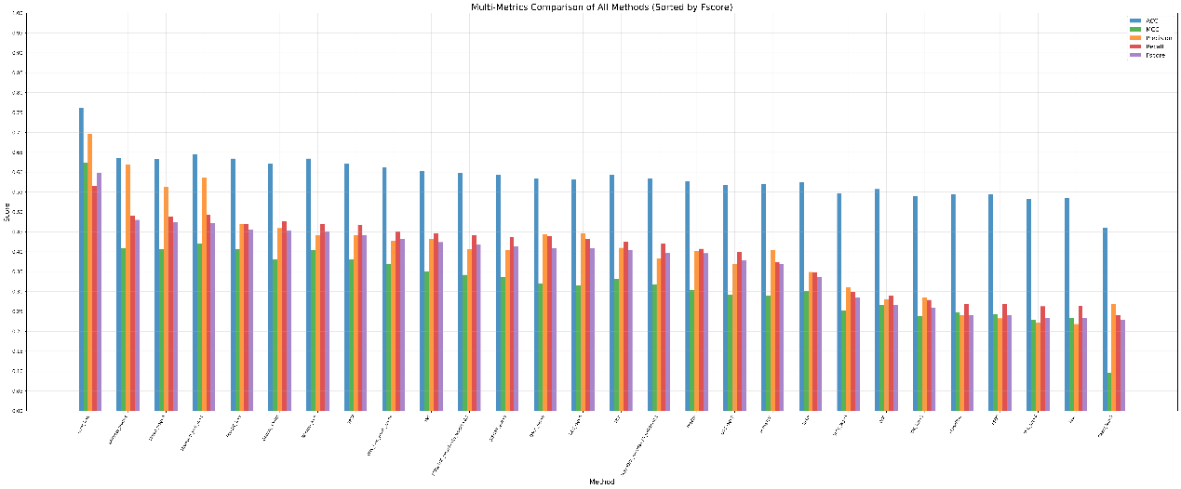
All Methods Ranking (Sorted by Fscore)
Rank | Method Name | Parameters | ACC | MCC | Precision | Recall | Fscore
1 | Kmer | k=8 | 0.7606 | 0.6238 | 0.6959 | 0.566 | 0.599
2 | NMBroto | nlag=4 | 0.6353 | 0.4094 | 0.6183 | 0.4915 | 0.48
3 | Moran | nlag=4 | 0.632 | 0.4064 | 0.5624 | 0.4882 | 0.475
4 | Mismatch | k=6;m=1 | 0.6453 | 0.4212 | 0.5869 | 0.4926 | 0.472
5 | PseKNC | k=6 | 0.6343 | 0.4067 | 0.4693 | 0.4689 | 0.4549
6 | Z-curve | 144bit | 0.6217 | 0.3815 | 0.4592 | 0.4763 | 0.4534
7 | RCKmer | k=6 | 0.6343 | 0.4029 | 0.4407 | 0.4694 | 0.4516
8 | TPCP | - | 0.6221 | 0.3814 | 0.4403 | 0.4682 | 0.441
9 | W2V | k=6;ws=5;vs=64 | 0.6126 | 0.3685 | 0.4274 | 0.4498 | 0.432
10 | TNC | - | 0.6026 | 0.3502 | 0.4331 | 0.4465 | 0.4241
11 | SCPseTNC | lamada=10;weight=0.1 | 0.5989 | 0.3421 | 0.4068 | 0.4421 | 0.4189
12 | CKSNAP | gap=5 | 0.5939 | 0.3366 | 0.4038 | 0.4359 | 0.4132
13 | DACC | lag=6 | 0.5844 | 0.3199 | 0.4439 | 0.4385 | 0.4095
14 | DCC | lag=6 | 0.5812 | 0.3162 | 0.4455 | 0.433 | 0.4093
15 | MMI | - | 0.593 | 0.3326 | 0.4097 | 0.426 | 0.4041
16 | SCPseDNC | lamada=10;weight=0.1 | 0.5837 | 0.3176 | 0.3823 | 0.4203 | 0.3976
17 | PseEIIP | - | 0.5762 | 0.3041 | 0.402 | 0.4074 | 0.3959
18 | DAC | lag=5 | 0.5673 | 0.2911 | 0.3681 | 0.3996 | 0.379
19 | PCPseTNC | - | 0.5707 | 0.2905 | 0.403 | 0.3746 | 0.3689
20 | DPCP | - | 0.5742 | 0.3012 | 0.3492 | 0.3487 | 0.3366
21 | TACC | lag=5 | 0.5475 | 0.2516 | 0.3103 | 0.2982 | 0.2856
22 | DNC | - | 0.5572 | 0.2672 | 0.2807 | 0.2889 | 0.2659
23 | TAC | lag=5 | 0.5394 | 0.2378 | 0.2857 | 0.2788 | 0.2602
24 | PCPseDNC | - | 0.5448 | 0.2476 | 0.2405 | 0.2693 | 0.241
25 | ASDC | - | 0.5433 | 0.2419 | 0.2323 | 0.2681 | 0.2408
26 | TCC | lag=6 | 0.5329 | 0.2284 | 0.2214 | 0.2627 | 0.2338
27 | NAC | - | 0.5343 | 0.2344 | 0.2183 | 0.2635 | 0.2335
28 | Geary | lag=3 | 0.4602 | 0.0962 | 0.2685 | 0.2409 | 0.2284

GRU:
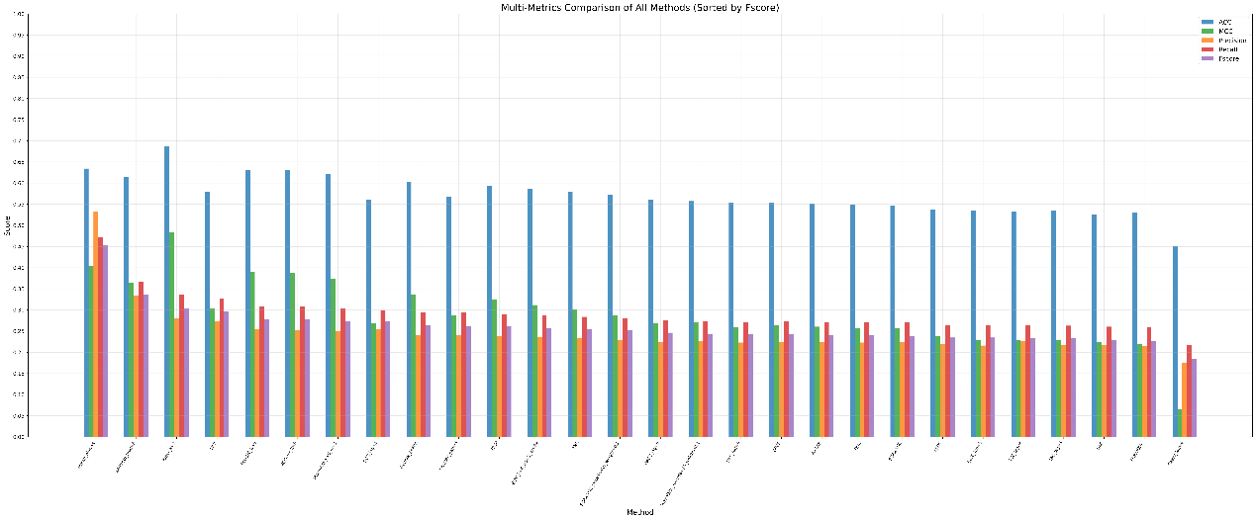
All Methods Ranking (Sorted by Fscore)
Rank | Method Name | Parameters | ACC | MCC | Precision | Recall | Fscore
1 | Moran | nlag=4 | 0.6342 | 0.4042 | 0.5332 | 0.4723 | 0.4533
2 | NMBroto | nlag=3 | 0.6143 | 0.3643 | 0.3345 | 0.3662 | 0.3357
3 | Kmer | k=7 | 0.686 | 0.4843 | 0.2795 | 0.3357 | 0.304
4 | MMI | - | 0.5788 | 0.3032 | 0.2736 | 0.3269 | 0.2959
5 | PseKNC | k=6 | 0.6314 | 0.39 | 0.2538 | 0.3086 | 0.2778
6 | RCKmer | k=6 | 0.6304 | 0.3875 | 0.2528 | 0.3083 | 0.2772
7 | Mismatch | k=6;m=1 | 0.6217 | 0.3737 | 0.2497 | 0.3043 | 0.2733
8 | DCC | lag=4 | 0.5606 | 0.2682 | 0.2547 | 0.2983 | 0.2728
9 | Z-curve | 144bit | 0.6018 | 0.3361 | 0.2415 | 0.2939 | 0.2647
10 | CKSNAP | gap=5 | 0.5669 | 0.288 | 0.2414 | 0.2942 | 0.261
11 | TPCP | - | 0.593 | 0.3251 | 0.2388 | 0.2906 | 0.2605
12 | W2V | k=4;ws=5;vs=64 | 0.587 | 0.3117 | 0.236 | 0.2867 | 0.2578
13 | TNC | - | 0.5789 | 0.302 | 0.2334 | 0.2836 | 0.2539
14 | SCPseTNC | lamada=10;weight=0.1 | 0.5726 | 0.2876 | 0.2297 | 0.2802 | 0.2516
15 | DACC | lag=6 | 0.5607 | 0.2676 | 0.2248 | 0.2747 | 0.2461
16 | SCPseDNC | lamada=10;weight=0.1 | 0.5572 | 0.27 | 0.2258 | 0.2741 | 0.2438
17 | DAC | lag=6 | 0.5536 | 0.2588 | 0.2229 | 0.2717 | 0.2427
18 | DPCP | - | 0.5533 | 0.2632 | 0.2244 | 0.2721 | 0.2421
19 | PseEIIP | - | 0.5518 | 0.2603 | 0.2241 | 0.2713 | 0.2415
20 | DNC | - | 0.5487 | 0.2566 | 0.2228 | 0.2701 | 0.2398
21 | PCPseTNC | - | 0.5472 | 0.2571 | 0.2232 | 0.2699 | 0.2391
22 | ASDC | - | 0.5373 | 0.2386 | 0.2191 | 0.2648 | 0.2347
23 | TACC | lag=5 | 0.5349 | 0.2281 | 0.2159 | 0.2632 | 0.2346
24 | TCC | lag=6 | 0.5334 | 0.2291 | 0.2264 | 0.2631 | 0.2341
25 | TAC | lag=5 | 0.534 | 0.2287 | 0.2163 | 0.2628 | 0.2337
26 | NAC | - | 0.5266 | 0.2237 | 0.2162 | 0.2602 | 0.2298
27 | PCPseDNC | - | 0.5309 | 0.2201 | 0.2147 | 0.2596 | 0.2264
28 | Geary | lag=4 | 0.4509 | 0.0651 | 0.1745 | 0.2167 | 0.1837

Transformer
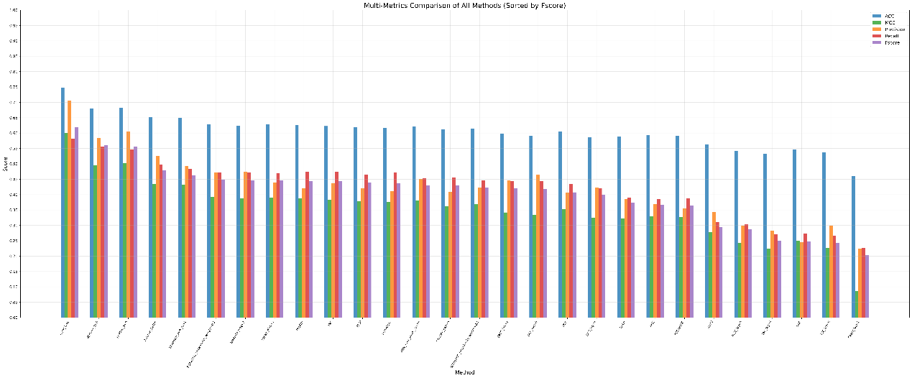
All Methods Ranking (Sorted by Fscore)
Rank | Method Name | Parameters | ACC | MCC | Precision | Recall | Fscore
1 | Kmer | k=8 | 0.747 | 0.6007 | 0.7059 | 0.5822 | 0.6183
2 | RCKmer | k=6 | 0.6797 | 0.4961 | 0.5845 | 0.5553 | 0.5598
3 | PseKNC | k=6 | 0.6824 | 0.5019 | 0.6058 | 0.5469 | 0.5552
4 | Z-curve | 144bit | 0.6517 | 0.4344 | 0.5247 | 0.497 | 0.478
5 | Mismatch | k=6;m=1 | 0.6499 | 0.4322 | 0.4931 | 0.4828 | 0.463
6 | SCPseTNC | lamada=10;weight=0.1 | 0.6291 | 0.3927 | 0.4708 | 0.4712 | 0.4492
7 | NMBroto | nlag=3 | 0.6245 | 0.3881 | 0.4735 | 0.471 | 0.447
8 | Moran | nlag=3 | 0.6281 | 0.3908 | 0.4397 | 0.4701 | 0.4454
9 | PseEIIP | - | 0.6258 | 0.388 | 0.4208 | 0.475 | 0.4443
10 | TNC | - | 0.6227 | 0.3838 | 0.4378 | 0.4743 | 0.4432
11 | TPCP | - | 0.6197 | 0.3776 | 0.4198 | 0.4657 | 0.4383
12 | PCPseTNC | - | 0.6171 | 0.3763 | 0.4119 | 0.4719 | 0.4376
13 | W2V | k=4;ws=5;vs=64 | 0.6209 | 0.3799 | 0.4517 | 0.4541 | 0.4307
14 | CKSNAP | gap=3 | 0.6112 | 0.3617 | 0.4095 | 0.4547 | 0.4288
15 | SCPseDNC | lamada=10;weight=0.1 | 0.6139 | 0.3679 | 0.4218 | 0.4455 | 0.4236
16 | DACC | lag=6 | 0.5985 | 0.3421 | 0.4452 | 0.4442 | 0.4203
17 | DCC | lag=6 | 0.5921 | 0.334 | 0.4639 | 0.4437 | 0.4181
18 | MMI | - | 0.6052 | 0.3517 | 0.407 | 0.4347 | 0.4075
19 | DAC | lag=6 | 0.5869 | 0.324 | 0.4222 | 0.4201 | 0.3986
20 | DPCP | - | 0.5879 | 0.3228 | 0.3844 | 0.3907 | 0.3736
21 | DNC | - | 0.5933 | 0.3294 | 0.3696 | 0.3857 | 0.3663
22 | PCPseDNC | - | 0.5901 | 0.3279 | 0.3546 | 0.3875 | 0.3638
23 | ASDC | - | 0.5641 | 0.2779 | 0.3431 | 0.3104 | 0.2945
24 | TACC | lag=5 | 0.5418 | 0.2436 | 0.2997 | 0.3025 | 0.2871
25 | TAC | lag=4 | 0.5326 | 0.2238 | 0.2834 | 0.2708 | 0.2496
26 | NAC | - | 0.5472 | 0.2496 | 0.2452 | 0.2735 | 0.248
27 | TCC | lag=6 | 0.5367 | 0.2272 | 0.2997 | 0.267 | 0.2435
28 | Geary | lag=2 | 0.46 | 0.0866 | 0.2235 | 0.2257 | 0.2034

- Model Ensemble
Resampling Method:
Random Forest:
Overall:
Resampling Method | ACC | MCC | Precision | Recall | Fscore | BACC | AUC
No Resampling | 0.752 | 0.6028 | 0.8367 | 0.5699 | 0.5967 | 0.5699 | 0.8994
SMOTE | 0.758 | 0.6175 | 0.7094 | 0.624 | 0.6545 | 0.624 | 0.907
ADASYN | 0.7545 | 0.6073 | 0.8405 | 0.5886 | 0.6018 | 0.5886 | 0.8993
Random Oversampling | 0.7629 | 0.6207 | 0.8596 | 0.5948 | 0.6349 | 0.5948 | 0.9093
NearMiss | 0.4766 | 0.2404 | 0.7758 | 0.4066 | 0.3362 | 0.4066 | 0.7475
Random Downsampling | 0.486 | 0.2582 | 0.8036 | 0.4114 | 0.3484 | 0.4114 | 0.8019
Per-Class:
No Resampling
Class | Precision | Recall | Fscore
Cytoplasm | 0.7062 | 0.8668 | 0.7782
Endoplasmic_reticulum | 0.9552 | 0.2783 | 0.4293
Extracellular_region | 0.8000 | 0.0503 | 0.0940
Mitochondria | 0.9385 | 0.8133 | 0.8708
Nucleus | 0.7837 | 0.8407 | 0.8111

SMOTE
Class | Precision | Recall | Fscore
Cytoplasm | 0.7575 | 0.8162 | 0.7856
Endoplasmic_reticulum | 0.7399 | 0.4793 | 0.5800
Extracellular_region | 0.3131 | 0.1758 | 0.2231
Mitochondria | 0.9540 | 0.8036 | 0.8714
Nucleus | 0.7827 | 0.8449 | 0.8123

ADASYN
Class | Precision | Recall | Fscore
Cytoplasm | 0.7118 | 0.8642 | 0.7806
Endoplasmic_reticulum | 0.9460 | 0.2735 | 0.4233
Extracellular_region | 0.8800 | 0.0523 | 0.0982
Mitochondria | 0.8805 | 0.9089 | 0.8939
Nucleus | 0.7840 | 0.8440 | 0.8128

Random Oversampling
Class | Precision | Recall | Fscore
Cytoplasm | 0.7298 | 0.8487 | 0.7847
Endoplasmic_reticulum | 0.9043 | 0.3890 | 0.5414
Extracellular_region | 0.9357 | 0.0991 | 0.1775
Mitochondria | 0.9528 | 0.7804 | 0.8571
Nucleus | 0.7753 | 0.8569 | 0.8139

NearMiss
Class | Precision | Recall | Fscore
Cytoplasm | 0.4533 | 0.9976 | 0.6232
Endoplasmic_reticulum | 1.0000 | 0.0545 | 0.1021
Extracellular_region | 0.7000 | 0.0215 | 0.0416
Mitochondria | 0.7591 | 0.9135 | 0.8270
Nucleus | 0.9668 | 0.0458 | 0.0871

Random Downsampling
Class | Precision | Recall | Fscore
Cytoplasm | 0.4580 | 0.9973 | 0.6275
Endoplasmic_reticulum | 0.9690 | 0.0421 | 0.0800
Extracellular_region | 0.8431 | 0.0479 | 0.0895
Mitochondria | 0.7479 | 0.9001 | 0.8154
Nucleus | 1.0000 | 0.0696 | 0.1296

Transformer：
Overall:
Resampling Method | ACC | MCC | Precision | Recall | Fscore | BACC | AUC
No Resampling | 0.7427 | 0.5978 | 0.6864 | 0.5942 | 0.6197 | 0.5942 | 0.8616
SMOTE | 0.7558 | 0.613 | 0.7293 | 0.593 | 0.6325 | 0.593 | 0.854
ADASYN | 0.7442 | 0.5994 | 0.7113 | 0.5972 | 0.6299 | 0.5972 | 0.8614
Random Oversampling | 0.7581 | 0.615 | 0.7737 | 0.5948 | 0.6391 | 0.5948 | 0.8492
NearMiss | 0.5166 | 0.2799 | 0.5082 | 0.4078 | 0.3917 | 0.4078 | 0.7407
Random Downsampling | 0.5548 | 0.3474 | 0.6096 | 0.4751 | 0.4571 | 0.4751 | 0.7649

Per-Class:
No Resampling
Class | Precision | Recall | Fscore
Cytoplasm | 0.7701 | 0.7919 | 0.7804
Endoplasmic_reticulum | 0.6097 | 0.5141 | 0.5507
Extracellular_region | 0.4283 | 0.2246 | 0.2611
Mitochondria | 0.8469 | 0.6081 | 0.7030
Nucleus | 0.7770 | 0.8323 | 0.8033

SMOTE
Class | Precision | Recall | Fscore
Cytoplasm | 0.7438 | 0.8293 | 0.7839
Endoplasmic_reticulum | 0.6914 | 0.5123 | 0.5865
Extracellular_region | 0.5495 | 0.1788 | 0.2674
Mitochondria | 0.8759 | 0.6149 | 0.7179
Nucleus | 0.7860 | 0.8296 | 0.8068

ADASYN
Class | Precision | Recall | Fscore
Cytoplasm | 0.7523 | 0.8142 | 0.7805
Endoplasmic_reticulum | 0.6321 | 0.5054 | 0.5470
Extracellular_region | 0.4741 | 0.2069 | 0.2758
Mitochondria | 0.9098 | 0.6462 | 0.7472
Nucleus | 0.7880 | 0.8131 | 0.7991

Random Oversampling
Class | Precision | Recall | Fscore
Cytoplasm | 0.7309 | 0.8387 | 0.7808
Endoplasmic_reticulum | 0.7700 | 0.4802 | 0.5897
Extracellular_region | 0.6754 | 0.1663 | 0.2593
Mitochondria | 0.9057 | 0.6578 | 0.7584
Nucleus | 0.7862 | 0.8309 | 0.8075

NearMiss
Class | Precision | Recall | Fscore
Cytoplasm | 0.5636 | 0.8711 | 0.6830
Endoplasmic_reticulum | 0.2303 | 0.2296 | 0.1891
Extracellular_region | 0.2339 | 0.1110 | 0.1405
Mitochondria | 0.8029 | 0.5761 | 0.5948
Nucleus | 0.7103 | 0.2511 | 0.3511

Random Downsampling
Class | Precision | Recall | Fscore
Cytoplasm | 0.5257 | 0.9506 | 0.6767
Endoplasmic_reticulum | 0.5325 | 0.2479 | 0.3148
Extracellular_region | 0.4058 | 0.1222 | 0.1718
Mitochondria | 0.7250 | 0.8144 | 0.7530
Nucleus | 0.8590 | 0.2404 | 0.3694

Loss Function：
TF:
Overall:
Loss Function | ACC | MCC | Precision | Recall | Fscore | BACC | AUC
Cross Entropy (CE) | 0.7427 | 0.5978 | 0.6864 | 0.5942 | 0.6197 | 0.5942 | 0.8616
Weighted Cross Entropy (WCE) | 0.7482 | 0.6079 | 0.701 | 0.6358 | 0.6538 | 0.6358 | 0.8666
Focal Loss | 0.7467 | 0.6034 | 0.7125 | 0.6264 | 0.653 | 0.6264 | 0.8639
Lovász-softmax Loss | 0.7291 | 0.5742 | 0.7302 | 0.5785 | 0.6184 | 0.5785 | 0.8361
LDAM Loss | 0.7579 | 0.6199 | 0.7255 | 0.6395 | 0.6677 | 0.6395 | 0.8665

Per-Class：
Cross Entropy (CE)
Class | Precision | Recall | Fscore
Cytoplasm | 0.7701 | 0.7919 | 0.7804
Endoplasmic_reticulum | 0.6097 | 0.5141 | 0.5507
Extracellular_region | 0.4283 | 0.2246 | 0.2611
Mitochondria | 0.8469 | 0.6081 | 0.7030
Nucleus | 0.7770 | 0.8323 | 0.8033

Weighted Cross Entropy (WCE)
Class | Precision | Recall | Fscore
Cytoplasm | 0.7547 | 0.7983 | 0.7744
Endoplasmic_reticulum | 0.7011 | 0.5388 | 0.6044
Extracellular_region | 0.3876 | 0.2552 | 0.2861
Mitochondria | 0.8652 | 0.7721 | 0.7990
Nucleus | 0.7965 | 0.8149 | 0.8052

Focal Loss
Class | Precision | Recall | Fscore
Cytoplasm | 0.7519 | 0.7956 | 0.7723
Endoplasmic_reticulum | 0.6700 | 0.5320 | 0.5916
Extracellular_region | 0.4556 | 0.2414 | 0.2963
Mitochondria | 0.9017 | 0.7422 | 0.8041
Nucleus | 0.7833 | 0.8208 | 0.8005

Lovász-softmax Loss
Class | Precision | Recall | Fscore
Cytoplasm | 0.7162 | 0.8210 | 0.7635
Endoplasmic_reticulum | 0.6628 | 0.4829 | 0.5492
Extracellular_region | 0.5597 | 0.1990 | 0.2710
Mitochondria | 0.9278 | 0.6132 | 0.7288
Nucleus | 0.7845 | 0.7764 | 0.7797

LDAM Loss
Class | Precision | Recall | Fscore
Cytoplasm | 0.7663 | 0.7966 | 0.7798
Endoplasmic_reticulum | 0.6756 | 0.5345 | 0.5953
Extracellular_region | 0.4918 | 0.2336 | 0.3119
Mitochondria | 0.9163 | 0.7884 | 0.8430
Nucleus | 0.7773 | 0.8444 | 0.8086

Base Model – Random Forest
Overall:
Methods | ACC | MCC | Precision | Recall | Fscore | BACC | AUC
SMOTE + RandomForest | 0.7598 | 0.6233 | 0.6951 | 0.6561 | 0.6681 | 0.6561 | 0.9085
Per-Class:
Cytoplasm | 0.7679 | 0.8035 | 0.7852
Endoplasmic_reticulum | 0.7198 | 0.4907 | 0.5826
Extracellular_region | 0.3168 | 0.2169 | 0.2551
Mitochondria | 0.8802 | 0.9237 | 0.9006
Nucleus | 0.7908 | 0.8453 | 0.8170

Base Model – Transformer
Methods | ACC | MCC | Precision | Recall | Fscore | BACC | AUC
Random Oversampling + LDAM Loss | 0.7616 | 0.6254 | 0.733 | 0.6335 | 0.6637 | 0.6335 | 0.8602

Per-Class
Cytoplasm | 0.7643 | 0.8121 | 0.7864
Endoplasmic_reticulum | 0.6818 | 0.5705 | 0.6198
Extracellular_region | 0.5736 | 0.2399 | 0.3322
Mitochondria | 0.8621 | 0.7106 | 0.7733
Nucleus | 0.7830 | 0.8345 | 0.8070

Weighted Fusion：
Global Fusion Weight:
Weight Type | Value
RF Weight (α) | 0.3960
TF Weight (1−α) | 0.6040

Per-Class Fusion Weight:
Subcellular Localization Class | RF Weight (α) | TF Weight (1−α)
Cytoplasm | 0.2900 | 0.7100
Endoplasmic_reticulum | 0.2600 | 0.7400
Extracellular_region | 0.0400 | 0.9600
Mitochondria | 0.3800 | 0.6200
Nucleus | 0.3700 | 0.6300

Overall:
Model | ACC | MCC | BACC | Precision | Recall | Fscore | AUC
RandomForest (Train) | 0.7857 | 0.6662 | 0.6905 | 0.7265 | 0.6905 | 0.7001 | 0.9246
RandomForest (Combined) | 0.7913 | 0.6749 | 0.6927 | 0.7344 | 0.6927 | 0.7061 | 0.9325
Transformer (Train) | 0.7716 | 0.6426 | 0.6639 | 0.7745 | 0.6639 | 0.6845 | 0.8629
Transformer (Combined) | 0.7819 | 0.6585 | 0.6636 | 0.7591 | 0.6636 | 0.6891 | 0.8690
Fusion (Global Weight) | 0.8035 | 0.6918 | 0.6937 | 0.7715 | 0.6937 | 0.7139 | 0.9278
Fusion (Per-Class Weight) | 0.8158 | 0.7107 | 0.6912 | 0.8412 | 0.6912 | 0.7132 | 0.8901

Per-Class:
Class | Metric | RF(Train) | RF(Combined) | TF(Train) | TF(Combined) | Fusion(Global) | Fusion(Per-Class)
Cytoplasm | Precision | 0.8013 | 0.8100 | 0.7430 | 0.7870 | 0.7921 | 0.7965
Cytoplasm | Recall | 0.8264 | 0.8352 | 0.8527 | 0.8242 | 0.8681 | 0.8791
Cytoplasm | Fscore | 0.8132 | 0.8220 | 0.7937 | 0.8040 | 0.8281 | 0.8350
Endoplasmic_reticulum | Precision | 0.8102 | 0.7926 | 0.6776 | 0.7432 | 0.8474 | 0.8654
Endoplasmic_reticulum | Recall | 0.5712 | 0.5702 | 0.5960 | 0.5952 | 0.5657 | 0.5655
Endoplasmic_reticulum | Fscore | 0.6641 | 0.6567 | 0.6306 | 0.6535 | 0.6715 | 0.6721
Extracellular_region | Precision | 0.3178 | 0.3381 | 0.7083 | 0.4813 | 0.4662 | 0.8167
Extracellular_region | Recall | 0.2622 | 0.2782 | 0.2199 | 0.2032 | 0.2372 | 0.1872
Extracellular_region | Fscore | 0.2833 | 0.3029 | 0.3192 | 0.2700 | 0.3015 | 0.2896
Mitochondria | Precision | 0.8907 | 0.9133 | 0.9181 | 0.9857 | 0.9157 | 0.8955
Mitochondria | Recall | 0.9333 | 0.9167 | 0.8500 | 0.8333 | 0.9333 | 0.9333
Mitochondria | Fscore | 0.9050 | 0.9093 | 0.8676 | 0.8899 | 0.9193 | 0.9096
Nucleus | Precision | 0.8127 | 0.8180 | 0.8254 | 0.7981 | 0.8359 | 0.8318
Nucleus | Recall | 0.8596 | 0.8632 | 0.8007 | 0.8619 | 0.8644 | 0.8908
Nucleus | Fscore | 0.8350 | 0.8396 | 0.8116 | 0.8279 | 0.8493 | 0.8596

- Hyperparameter Selection (Bayesian Optimization, Based on Fusion MCC: 50% TF, 50% RF, 3Fold):
Random Forest (RF) Hyperparameters
Hyperparameter | Description | Search Range | Optimal Value
n_estimators | Number of decision trees in the random forest ensemble | [100, 150, 200] | 200
max_depth | Maximum depth of each decision tree (None = no restriction) | [None, 10, 20, 30, 40] | 30
min_samples_split | Minimum samples required to split an internal node | [2, 5, 8, 10] | 2
min_samples_leaf | Minimum samples required to form a leaf node | [1, 2, 5, 8] | 1
max_features | Number of features considered for the optimal split | ['auto', 'sqrt', 'log2'] | 'sqrt'
bootstrap | Whether bootstrap sampling is used for model training | [True, False] | False

Transformer (TF) Hyperparameters
Hyperparameter | Description | Search Range | Optimal Value
d_model | Hidden feature dimension of the Transformer model | [16, 32, 64] | 16
nhead | Number of heads in the multi-head attention mechanism | [2, 4] | 2
num_layers | Number of stacked Transformer encoder layers | [1, 2, 3] | 2
dim_feedforward | Hidden dimension of the feed-forward neural network | [32, 64, 128] | 32
dropout | Dropout probability for model regularization | [0.0, 0.1, 0.2] | 0.1

Fusion Model Overall:
Metric | Value
ACC | 0.8031
MCC | 0.6920
BACC | 0.6928
Precision | 0.8047
Recall | 0.6928
Fscore | 0.7214
AUC | 0.9302

10-Fold CV Average Per-Class Results (Precision / Recall / Fscore)
Class | Precision | Recall | Fscore
Cytoplasm | 0.7959 | 0.8648 | 0.8273
Endoplasmic_reticulum | 0.8792 | 0.5462 | 0.6642
Extracellular_region | 0.6096 | 0.2865 | 0.3741
Mitochondria | 0.9181 | 0.9000 | 0.8992
Nucleus | 0.8209 | 0.8666 | 0.8421

- Analysis
Test Set Results:
Overall:
Model | ACC | MCC | BACC | Precision | Recall | Fscore | AUC
mRNALocator-imb | 0.8065 | 0.6949 | 0.6817 | 0.8299 | 0.6817 | 0.7253 | 0.9323
iLoc_mRNA | 0.5459 | 0.3811 | 0.4992 | 0.6475 | 0.4992 | 0.4417 | 0.5391
RNATracker (50 epoch) | 0.6326 | 0.2901 | 0.6037 | 0.5234 | 0.6037 | 0.5558 | 0.7770
RNATracker (100 epoch) | 0.6157 | 0.2776 | 0.5889 | 0.5169 | 0.5889 | 0.5434 | 0.7706
iLoc_mRNA | 0.6328 | -0.0479 | 0.6098 | 0.5825 | 0.6098 | 0.5783 | 0.6820

Per-Model:
mRNALocator-imb
Class\Metric | Precision | Recall | Fscore
Cytoplasm | 0.8018 | 0.8607 | 0.8302
Endoplasmic_reticulum | 0.9194 | 0.5561 | 0.6930
Extracellular_region | 0.6889 | 0.2520 | 0.3690
Mitochondria | 0.9455 | 0.8525 | 0.8966
Nucleus | 0.7938 | 0.8872 | 0.8379

iLoc_mRNA
Class\Metric | Precision | Recall | Fscore
Cytoplasm | 0.5909 | 0.7982 | 0.6791
Endoplasmic_reticulum | 0.5288 | 0.9854 | 0.6882
Extracellular_region | 0.1176 | 0.3089 | 0.1704
Mitochondria | 1.0000 | 0.1803 | 0.3056
Nucleus | 1.0000 | 0.2233 | 0.3651

RNATracker (Made compatibility modifications for TensorFlow, with everything else unchanged. Data processing was also balanced, as the MCC was too low with unbalanced data.):
50 epoch:
Class | Precision | Recall | Fscore
Cytoplasm | 0.7900 | 0.7094 | 0.7475
Endoplasmic_reticulum | 0.2931 | 0.3317 | 0.3112
Extracellular_region | 0.2874 | 0.3902 | 0.3310
Mitochondria | 0.7229 | 0.9836 | 0.8333

100 epoch:
Class | Precision | Recall | Fscore
Cytoplasm | 0.7914 | 0.6864 | 0.7352
Endoplasmic_reticulum | 0.2832 | 0.3122 | 0.2970
Extracellular_region | 0.2692 | 0.4553 | 0.3384
Mitochondria | 0.7237 | 0.9016 | 0.8029

mRNALoc (Fixed Python errors in PSEKNC, set SVM threshold to 0.1, and tested by inputting the test set FASTA files separately. Predictions labeled "Location Found" are counted as false negatives for the corresponding category.):
Class | Precision | Recall | Fscore
Cytoplasm | 0.7196 | 0.6457 | 0.6823
Endoplasmic_reticulum | 0.4815 | 0.7429 | 0.5857
Extracellular_region | 0.2619 | 0.2683 | 0.2629
Mitochondria | 0.8837 | 0.7308 | 0.8000
Nucleus | 0.7651 | 0.6615 | 0.7095

SHAP：
Top 30 Features (Total Impact Descending)
Rank | Feature Name | Total Impact | Cyt Mean | Endo Mean | Extra Mean | Mito Mean | Nucl Mean
1 | CCCTG | 0.001813 | 0.000847 | -0.000144 | -0.000507 | 0.000060 | -0.000256
2 | CCT_MW-Daltons | 0.001539 | 0.000021 | -0.000364 | -0.000405 | 0.000124 | 0.000624
3 | CCT_Nucleosome-Rigid | 0.001527 | 0.000228 | -0.000283 | -0.000480 | 0.000132 | 0.000403
4 | GGGCC | 0.001403 | 0.000536 | 0.000031 | -0.000702 | 0.000130 | 0.000005
5 | GCAGT | 0.001383 | -0.000364 | -0.000139 | -0.000189 | 0.000176 | 0.000515
6 | CCT | 0.001345 | 0.000266 | -0.000261 | -0.000412 | 0.000077 | 0.000330
7 | CCT_Nucleosome | 0.001093 | 0.000397 | -0.000102 | -0.000444 | 0.000094 | 0.000055
8 | CCT_Trinucleotide GC Content | 0.001088 | 0.000306 | -0.000195 | -0.000349 | 0.000076 | 0.000162
9 | CCT_Consensus_roll | 0.001074 | 0.000307 | -0.000148 | -0.000389 | 0.000093 | 0.000137
10 | CCC_Nucleosome positioning | 0.001015 | 0.000242 | 0.000014 | -0.000508 | 0.000095 | 0.000157
11 | GGG | 0.001000 | 0.000193 | 0.000035 | -0.000500 | 0.000051 | 0.000221
12 | CCT_Nucleosome positioning | 0.000952 | 0.000254 | -0.000102 | -0.000373 | 0.000087 | 0.000135
13 | CTGGG | 0.000951 | 0.000188 | -0.000268 | -0.000208 | 0.000089 | 0.000198
14 | CCC_Nucleosome | 0.000950 | 0.000191 | 0.000002 | -0.000475 | 0.000104 | 0.000177
15 | CCCGG | 0.000935 | 0.000089 | -0.000082 | -0.000385 | 0.000089 | 0.000290
16 | AAAA | 0.000899 | 0.000015 | -0.000208 | -0.000162 | -0.000079 | 0.000434
17 | CCT_Dnase I-Rigid | 0.000896 | 0.000140 | -0.000173 | -0.000275 | 0.000064 | 0.000244
18 | CCC_Nucleosome-Rigid | 0.000839 | 0.000030 | -0.000153 | -0.000266 | 0.000095 | 0.000294
19 | CGA_Dnase I-Rigid | 0.000828 | -0.000158 | -0.000123 | -0.000133 | 0.000036 | 0.000378
20 | CCT_Dnase I | 0.000822 | 0.000135 | -0.000196 | -0.000215 | 0.000055 | 0.000221
21 | GGG_Nucleosome-Rigid | 0.000819 | 0.000318 | 0.000086 | -0.000291 | 0.000006 | -0.000118
22 | GCCCT | 0.000810 | 0.000265 | 0.000046 | -0.000405 | 0.000076 | 0.000018
23 | GCCC | 0.000807 | 0.000313 | -0.000022 | -0.000382 | 0.000071 | 0.000020
24 | CCTGC | 0.000801 | 0.000074 | -0.000170 | -0.000230 | 0.000083 | 0.000243
25 | GAAGC | 0.000774 | -0.000144 | -0.000095 | -0.000106 | -0.000043 | 0.000387
26 | CGA_Nucleosome positioning | 0.000768 | -0.000089 | -0.000154 | -0.000142 | 0.000053 | 0.000331
27 | CCTGG | 0.000760 | 0.000247 | -0.000140 | -0.000240 | 0.000114 | 0.000019
28 | CTGCC | 0.000752 | 0.000051 | -0.000052 | -0.000324 | 0.000068 | 0.000258
29 | TGCCC | 0.000698 | 0.000233 | 0.000063 | -0.000313 | 0.000053 | -0.000036
30 | CGA_Dnase I | 0.000690 | -0.000106 | -0.000119 | -0.000120 | 0.000015 | 0.000330
